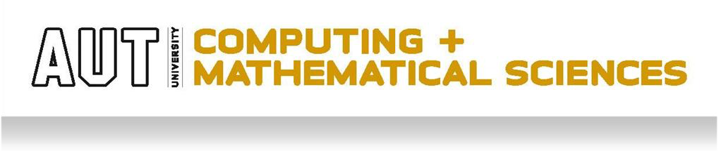
Team ASSIGNMENT COVERSHEET
ITPM (COMP507) Assignment 1 Part 1
Team Number: | Lab Time: |  | Lab TA:
Student ID  1. 25288226  2. 25285879  3. 21142315  4. 26345265 | First Name  Matthew  Isaiah  Rahul  Bradley |  | Surname  Rushmer  Thompson  Shankar  Ah Sam
Team Name: BIRM
TA names: Manpreet Dhanjal
Assignment due date: Sunday 20th September 2026 (8 am) |  | Date & time submitted:

Please read the following and place an X next to each statement to indicate your understanding:
It is my team’s responsibility to keep a copy of the assignment. | X
The team has signed and read the Student Statement below. | X
The team understands that a software program (Turnitin) that detects plagiarism and copying may be used on my assignment. | X

Plagiarism and Dishonesty are methods of cheating for the purposes of General Academic Regulations (GAR) http://www.aut.ac.nz/students/regulations.htm
Student’s Statement: This assessment is entirely our team’s work and has not been submitted in any other course of study. The team will submit a copy of this assessment to Turnitin if required. In this assessment, the team has acknowledged that to the best of the team’s ability:
- The source of direct quotes from the work of others
- The ideas of others (includes work from private or professional services, past assessments, other students, books, journals, cut/paste from internet sites and/or other materials)
- The source of diagrams
Signature:
1. Matthew Date: 22/06/2026
2. Isaiah Date: 22/06/2026
3. Rahul Date: 22/06/2026
4. Bradley Date: 22/06/2026

The information on this form is collected for the primary purpose of submitting your assignment for assessment. Other purposes of collection include receiving your acknowledgment of plagiarism policies and attending to administrative matters. If you choose not to complete all questions on this form, it may not be possible for the Faculty of Design and Creative Technologies to accept your assignment.

Communication Management Plan

Author: Matthew Rushmer, Isaiah Thompson

Date: 10/09/2026

Version: 1.0

Project Name: PMS Comparison

Stakeholder communications requirements:
Requirements | Role | Communication Method | Producer | Frequency
Daniel Vaipulu | Lecture | Email: daniel.vaipulu@aut.ac.nz | Matthew Rushmer | Monthly
Hnin Myat Mon | TA | Email: yuki.mon@aut.ac.nz | Either Matthew Rushmer (Team Lead) or Isaiah | Monthly
Gavin Zhao | TA | Email: gavin.zhao@autuni.ac.nz | Either Matthew Rushmer (Team Lead) or Isaiah | Monthly
Khin Khin Maw | Lab Tutor | Email: khin.khin.maw@aut.ac.nz | Either Matthew Rushmer (Team Lead) or Isaiah | Weekly
Manpreet Dhanjal | Lab Tutor | Email: manpreet.kaur.dhanjal@aut.ac.nz | Either Matthew Rushmer (Team Lead) or Isaiah | Weekly

Communications summary:

Stakeholders | Communications Name | Delivery Method/Format | Producer | Due/Frequency
Project steering committee | Weekly status report | Hard copy and short meeting | Kristin Maur | Wed. mornings at 9 AM
Sponsor and champion | Monthly status report | Hard copy and short meeting | Kristin Maur | First Thursday of month at 10 AM
Affected employees | Project announcement | Memo, e-mail, intranet site, and announcement at department meetings | Lucy Camerena and Mike Sundby | July 1, 2007
Project team | Weekly status report | Short meeting | All team members | Tues. afternoons at 2:00.

Comments/Guidelines:

General principles (the 5 Cs)

Correct: facts, figures, and terminology are accurate before sending; double-check numbers (budgets, dates, pricing) before they go to a stakeholder.

Concise: messages get to the point; no padding out an update to look thorough.

Clear: every message states its purpose and what action (if any) is expected of the reader.

Coherent: information is presented in a logical order (context → update → action needed).

Controlled: longer updates (status reports, meeting minutes) are structured under headings so key points are easy to find.

How we act as a team

Communicate professionally and respectfully at all times, in writing and in meetings — matches the Team Contract.

Respond to team messages within 24 hours, even if just to acknowledge and say when a full reply will follow.

Proactively share progress and blockers — don't wait to be asked; if a task is behind, say so before it becomes an issue.

Meetings

Arrive on time and stay focused on the agenda.

Every meeting has minutes recorded.

Escalation procedures for resolving issues:

How we handle team issues: Not every disagreement needs a formal process. When something comes up, we try to work through it at the lowest level first and only escalate if it's genuinely stuck.

Step 1: Talk it out (0–2 days)
Whoever's involved sorts it out between themselves a quick chat, a call, a message in the team channel. Most of what comes up (who's covering what, a scheduling clash, a disagreement over a task) gets resolved right here, and there's no need to log any of it.

Step 2: Bring in the Issue Manager (2–3 days after Step 1 stalls)
If it's still not sorted, it goes to Bradley. He logs it properly in the Issue Register what it's affecting, how urgent it is, and a suggested way forward then works with the people involved to get it resolved.

Step 3: Escalate to the Team Lead (2–3 days after Step 2 stalls)
If Bradley can't get it resolved, it goes to Mathew. He makes the final call, shuffles priorities or resources if that's what it takes, and updates the Issue Register with how it was resolved.

Step 4: Project Supervisor / Product Owner
Anything still unresolved after Step 3 or anything touching scope, budget, or people outside the team goes to Khin Khin Maw or Manpreet Dhanjal. They have the final say on the direction of the project, and this level is really only for things that put deadlines, deliverables, or the team's ability to function at risk.

Revision procedures for this document:

The Communications Management Plan changes when it needs to. If stakeholder feedback keeps saying the current approach isn't working, we revise it. Here's how.

Step 1: Collect feedback
Complaints about communication (too much detail, too little, updates slipping through, reports that don't make sense) surface through the usual channels: weekly client meetings, team meetings, notes in the minutes, or the Issue Register. One complaint is just an issue. The same complaint showing up again and again means the plan itself is worth revisiting.

Step 2: Assess the change
Matthew looks at the feedback against the Stakeholder Communications Analysis table, with Rahul giving input as Stakeholder Advisor. Between them they figure out what's actually wrong, whether it's frequency, format, channel, or the amount of detail for that stakeholder, and think through what changing it would mean elsewhere: other stakeholders, workload, timing. Only then do they agree to anything.

Step 3: Update the plan
Say they decide to move a stakeholder from monthly emails to weekly status calls. That change gets written into the plan, dated, and given a short note on what changed and why, so there's a trail showing how the plan has developed over time.

Step 4: Communicate the update
At the next team or client meeting, the update goes out to the team, and to the stakeholder if it affects them. The goal is simple: make sure everyone's clear on the new approach and actually sticks to it.

Change Management Plan

Date: 10/09/2026

Author: Isaiah Thompson, Matthew Rushmer, Rahul Shankar, Bradley Ah Sam

Version: 1

Project Name: PMS Comparison

Background
Be sure to plan for change at the beginning of the project. All projects will require some sort of changes during their lifetime. Plan ahead by having the process already defined and clearly documented. Change management is critical to completing your projects on schedule and on budget. Whether you’re working on your PMI PMP certification or an experience project manager, we’re sure you’ll find this change management plan template helpful.

Introduction
Start the development of your Project Change Management Plan with this template. This template is intended to support your project change management process.
Change Management is an important part of any project. Changes must be vetted and managed to ensure that they are within the scope of the project and are communicated to all stakeholders if they are approved. The process for submitting, reviewing, and approving changes must also be communicated to all stakeholders in order to properly set expectations. If changes are allowed to be submitted or are implemented in and unorganized way, any project is sure to fail. All projects must include a Change Management Plan as part of the overall Project Plan, it can either be included as a section in the Project Plan or as an appendix as a subsidiary management plan.
The Change Management Plan sets expectations on how the approach to changes will be managed, what defines a change, the purpose and role of the change control board, and the overall change management process. All stakeholders will be expected to submit or request changes to in accordance with this Change Management Plan and all requests and submissions will follow the process detailed herein.

Change Management Approach
This section of the Change Management Plan describes the approach the organization will use for managing change throughout the project. Throughout a project’s lifecycle there may only be a few or many changes submitted. The approach taken to manage these changes must be consistent and repeatable in order to provide a quality change management plan and process.
The Change Management approach ensures that all proposed changes are defined, reviewed, and agreed upon so they can be properly implemented and communicated to all stakeholders - and importantly that the implications of the change on the scope, budget and timeline are accounted for. This approach will also ensure that only changes within the scope of the project are approved and implemented or are clearly agreed to by those responsible for the timeline and budget for the overall project.
The Change Management approach is not to be confused with the Change Management Process which should be detailed later in this plan. The Change Management approach consists of three areas:
- Ensure changes are within scope and beneficial to the project
- Determine how the change will be implemented
- Manage the change as it is implemented
The Change Management process has been designed to make sure this approach is followed for all changes. By using this approach, the team will prevent unnecessary change from occurring and focus its time and resources only on beneficial changes within the project scope.

Definitions of Change
This section of the Change Management Plan defines the different types of changes that may be requested and considered for the project. These changes may include schedule change, budget change, scope change, or project document changes. Most changes will impact at least one of these areas and it is important to consider these impacts and how they will affect the project.
There are several types of changes which may be requested and considered for a project. Depending on the extent and type of proposed changes, changes to project documentation and the communication of these changes will be required to include any approved changes into the project plan and ensure all stakeholders are notified. Types of changes include:
Scheduling Changes: changes which will impact the previously approved project schedule. These changes may require fast tracking, crashing, or re-baselining the schedule depending on the significance of the impact.
Budget Changes: changes which will impact the approved project budget. These changes may require requesting additional funding, releasing funding which would no longer be required, or adding to project or management reserves. These may require changes to the cost baseline.
Scope Changes: changes which are necessary and impact the project’s scope which may be the result of unforeseen requirements which were not initially planned for. These changes may also impact budget and schedule. These changes may require revision to the WBS, the project scope statement, and other project documentation as necessary.
The project manager typically ensures that any approved changes are communicated to the project stakeholders. Additionally, as changes are approved, the project manager will ensure that the changes are captured in the project documentation where necessary. These document updates must then be communicated to the wider project team and potentially the stakeholders as well.

Change Control Board
Here the Change Management Plan describes the Change Control Board, the purpose of the board, and the members and their roles on the board. The change control board is the approval authority for all proposed project changes. If a change is not approved by the control board, then it will not be implemented with the project. The size and function of change control boards may vary depending on the organization, but their purpose and the roles and responsibilities are typically consistent.
The Change Control Board is the approval authority for all proposed change requests pertaining to a Project. The purpose of the Change Control Board is to review all change requests, determine their impacts on the project risk, scope, cost, and schedule, and to approve or deny each change request. The following chart provides a list of the Change Control Board members for a typical project:
Name | Position | Role
 | Project Sponsor | Chair
 | Project Manager | Secretary
 | Technical Lead | Co-Chair
 | Operations Lead | Member
As change requests are submitted using a Change Request Form to the Project Manager by the project team or via stakeholders, the Project Manager will log the requests in a Change Log and the Change Control Board will convene frequently to review all change requests. For a change request to be approved, all Change Control Board members must vote in favour. In the event more information is needed for a particular change request, the request will be deferred and sent back to the requestor for more information or clarification. If a change is deemed critical, an ad hoc Change Control Board meeting may be called in order to review the change prior to the next scheduled Change Control Board meeting.

Roles and Responsibilities
This section of the Change Management Plan describes the roles and responsibilities of project team members in regards to the change management process. It is important that everyone understands these roles and responsibilities as they work through the change management process. These roles and responsibilities must be communicated as part of the change management plan to all project stakeholders.
The following are roles and responsibilities for all change management efforts related to a typical project:
Project Sponsor:
- Approve all changes to budget/funding allocations
- Approve all changes to schedule baseline
- Approve any changes in project scope
- Chair the Change Control Board
Project Manager:
- Receive and log all change requests from project stakeholders
- Conduct preliminary risk, cost, schedule, scope analysis of change prior to Change Control Board
- Seek clarification from change requestors on any open issues or concerns
- Make documentation revisions/edits as necessary for all approved changes
- Participate on Change Control Board
Project Team / Stakeholders:
- Submit all change requests on standard organizational change request forms
- Provide all applicable information and detail on change request forms
- Be prepared to address questions regarding any submitted change requests
- Provide feedback as necessary on impact of proposed changes

Change Control Process
This part of the Change Management Plan should describe the change control process from beginning to end. Typically, a change control process would be an organisational standard and repeatable. This process is the tool which is used to ensure adherence to the organisation’s change management approach. By following all of the steps, the project team can successfully incorporate approved changes, communicate the changes, and update project documentation.
The Change Control Process for the project will follow the organisational standard change process for all projects. The project manager has overall responsibility for executing the change management process for each change request.
- Identify the need for a change (Stakeholders) – Change requestor will submit a completed change request form to the project manager.
- Log change in the change request register (Project Manager) – The project manager will keep a log of all submitted change requests throughout the project’s lifecycle.
- Evaluate the change (Project Manager, Team, Requestor) – The project manager will conduct a preliminary analysis on the impact of the change to risk, cost, schedule, and scope and seek clarification from team members and the change requestor.
- Submit change request to Change Control Board (Project Manager) – The project manager will submit the change request, as well as the preliminary analysis, to the Change Control Board for review.
- Obtain Decision on change request (Change Control Board) – The Change Control Board will discuss the proposed change and decide whether or not it will be approved based on all submitted information.
- Implement change (Project Manager) – If a change is approved by the Change Control Board, the project manager will update and re-baseline project documentation as necessary.

Change Request

Date: 10/09/2026

Author: Isaiah Thompson

Version: 1

Project Name: PMS Comparison

Date Request Submitted: 10/09/2026

Title of Change Request: Transition from Wiki to Microsoft Word and Canvas.

Change Order Number: 1

Submitted by: Isaiah Thompson

Change Category: Scope Schedule Cost ☑ Technology Role Phases
Requirements Other

Description of change requested:

Transition the self-hosted Wiki comparison to a simple word file posted on the AUT Canvas R&D assignment page.

Events that made this change necessary or desirable:

There was a meeting with shareholders. The shareholders were worried they were spending too much on a simple comparison website.

Justification for the change/why it is needed/desired to continue/complete the project:

This change is desirable due to greatly reducing cost and working hours. Cutting cost allows the schools budget to go elsewhere, making the shareholders happy. Cutting working hours allows the developers time to go somewhere else more needed, also making the shareholders happy. A large part of a successful project is keeping shareholders happy.

Impact of the proposed change on:
Scope: Due to not needing to develop Wiki server infrastructure, the scope is considered smaller.
Schedule: The comparison will come out faster because there is no wait for developers to make a Wiki server.
Cost: The cost would be greatly reduced due to not needing developers and hosting infrastructure.
Staffing: The developers would be removed from the project. The rest of the staff’s working hours remain unchanged.
Risk: The project hosting would now be reliant upon Canvas. If Canvas were to go down, our project would be unreadable. Switching to a word file may reduce the flexibility of what type of content we can show. For instance, interactivity on the comparison would no longer be possible.
Other: Users will no longer be able to edit the main comparison page due to the different nature of a word file compared to a Wiki server.

Suggested implementation if the change request is approved:

Write the PMS Comparison onto the word document instead of a separate website. Upload the word documents to the R&D Canvas page. Students will now be able to see the PMS Comparison sheet.

Required approvals:

Name/Title | Date | Approve/Reject
Isaiah Thompson | 10/09 | Approve
Matthew Rushmer | 17/09 | Approve
Bradley Ah Sam | 17/09 | Approve
Rahul Shankar | 17/09 | Approve

Scope Statement
Author: Rahul Shankar
Date: 14/09/2026
Version: 1.0


Project Title: PMS Comparison
Date: 14/09/2026 Prepared by: Rahul Shankar
Project Justification:

The purpose of the PMS Comparison project is to help R&D students choose a suitable Project Management System. At the moment, students do not have consistent guidance on which PMS would be suitable for their projects, so they may have to spend extra time researching different options themselves. This can also lead to students choosing different tools without knowing which ones are most suitable. The project will address this by creating a Wiki that compares two cloud-based PMS platforms and gives students useful information to help them make a decision.

Product Characteristics and Requirements:

The final product will be a Wiki aimed at R&D students. It will compare two cloud-based Project Management Systems and explain how they can be used across the five project management process groups: Initiating, Planning, Executing, Monitoring/Controlling and Closing. The information should be easy for students to understand and supported by reliable sources.

- 1. Functional Requirement 1: The Wiki must explain the criteria used to choose the two PMS platforms.

- 2. Functional Requirement 2: The Wiki must compare the two PMS platforms across all five project management process groups.

- 3. Functional Requirement 3: Information used in the comparison must be supported by reliable sources such as vendor information or scholarly sources.

- 4. Functional Requirement 4: The Wiki must organise the information so students can find content by PMS platform and project management process group.

- 5. Non-Functional Requirement: The Wiki must be easy to understand and suitable for R&D students who may not have advanced project management knowledge.

Product User Acceptance Criteria:

Time:
The PMS Comparison Wiki must be completed and ready for use by February 1st 2026.

Scope:
The Wiki must compare exactly two cloud-based PMS platforms, cover all five project management process groups and stay within the 4,500-word limit. Microsoft Project will not be selected as one of the two PMS platforms.

Stakeholder:
The final Wiki should be reviewed by the relevant ECMS/R&D stakeholder before it is released. Any important feedback or changes identified during the review should be completed before the Wiki is considered finished.

Summary of Project Deliverables Project management-related deliverables:
The project management deliverables will include the Business Case, Project Charter, Team
Contract, Scope Statement, Work Breakdown Structure (WBS), project schedule, cost baseline, Risk Register, Issue Register, status or milestone reports, meeting minutes, final project presentation, final project report and lessons-learned report.
Product-related deliverables:

1. PMS Comparison Wiki
A completed Wiki that compares the two selected cloud-based Project Management Systems.

- PMS Comparison Research
Research and comparison of the two PMS platforms across the five project management process groups, supported by reliable sources.

- PMS Selection and Recommendations
The criteria used to select the two PMS platforms, along with findings explaining why they are suitable options for R&D students.

Work Breakdown Structure & Project Schedule
Author: Matthew Rushmer, Isaiah Thompson, Rahul Shankar, Bradley Ah Sam
Date: 16/09/2026
Project Name: PMS Comparison (Cloud-Based Project Management Software Review – ECMS Wiki)

This document covers Assignment 1, Part 2, items 15 (Work Breakdown Structure, 20 marks) and 16 (Project Schedule, 20 marks). It builds directly on the Part 1 Business Case (budget $200,000; planning starts 1 Aug 2025; implementation complete 30 Dec 2025; Wiki live 1 Feb 2026) and the Project Charter’s stated Approach: Planning → Designing → Review → Feedback collection → Delivery.

15. Work Breakdown Structure (WBS)

15.1 Method and Rationale
This WBS uses a phase-based, deliverable-oriented decomposition built directly on the five phases already committed to in the Project Charter’s Approach section Planning, Designing, Review, Feedback collection, Delivery broken down into work packages of roughly 1–2 weeks of effort (the PMBOK "8/80 rule" sizing). This keeps Part 2 consistent with Part 1 instead of introducing a second, contradictory structure. Two research work packages (2.4 and 2.5) are sized at three weeks rather than the general one-to-two-week band: researching a full candidate PMS in depth across all five PMBOK process groups is genuinely larger in scope than the other leaf packages, so this is treated as a deliberate, justified exception to the sizing guideline rather than a violation of it.

15.2 WBS Hierarchy
0.0 PMS Comparison Wiki Project
├── 1.0 Planning
│ ├── 1.1 Finalise scope statement, quality goals, WBS & schedule baseline sign-off
│ ├── 1.2 Confirm PMS shortlisting criteria with supervisor
│ └── 1.3 Confirm ECMS infrastructure & Wiki workspace access
├── 2.0 Designing – PMS Research & Evaluation
│ ├── 2.1 Market scan of candidate cloud PMS tools (excl. Microsoft Project)
│ ├── 2.2 Apply shortlisting criteria & finalise the two PMS selections
│ ├── 2.3 Benchmark Microsoft Project’s feature set to derive comparison criteria
│ ├── 2.4 Research PMS A across all five PM process groups
│ ├── 2.5 Research PMS B across all five PM process groups
│ └── 2.6 Compile source list & APA references
├── 3.0 Designing – Wiki Content Development
│ ├── 3.1 Draft Wiki structure & navigation (by process group and by tool)
│ ├── 3.2 Write Initiating process group comparison
│ ├── 3.3 Write Planning process group comparison
│ ├── 3.4 Write Executing process group comparison
│ ├── 3.5 Write Monitoring/Controlling process group comparison
│ ├── 3.6 Write Closing process group comparison
│ └── 3.7 Compile intro/criteria pages & build out Wiki formatting
├── 4.0 Review & Feedback Collection
│ ├── 4.1 Internal team review (accuracy, citations, quality goals)
│ ├── 4.2 Word-count compliance check & trim to ≤4,500 words
│ ├── 4.3 Supervisor/TA review checkpoint
│ └── 4.4 Recruit & collect sample R&D student feedback
└── 5.0 Delivery
├── 5.1 Analyse feedback & revise content
├── 5.2 Final proofread, sign-off & publish Wiki to ECMS servers
├── 5.3 Announce Wiki to R&D coordinators/students
├── 5.4 Handover documentation to ECMS IT
└── 5.5 Milestone report (v2), lessons-learned report & project closure meeting
25 work packages across 5 phases every leaf item is small enough for one team member (or a clear pair) to own, and produces a checkable output.

15.3 WBS Dictionary
WBS # | Work Package | Deliverable / "Done" looks like | Owner
1.1 | Finalise scope, quality goals, WBS & schedule baseline sign-off | Signed-off scope statement (#14) with quality goals stated; this WBS and schedule approved by the team | Whole team, led by Matthew
1.2 | Confirm PMS shortlisting criteria with supervisor | Supervisor-agreed written criteria for shortlisting candidate PMS tools | Matthew
1.3 | Confirm ECMS infrastructure & Wiki workspace access | Confirmed lab/remote access to the Wiki platform for all 4 members | Rahul
2.1 | Market scan of candidate cloud PMS tools | Longlist of ≥5 candidate SaaS PMS tools (Microsoft Project excluded) | Isaiah
2.2 | Apply criteria & finalise 2 PMS selection | Final 2 PMS named, with the criteria-based rationale documented | Whole team, decision led by Matthew
2.3 | Benchmark MS Project feature set | One-page feature map of MS Project across the 5 process groups, used to derive comparison criteria (never listed as a selectable option) | Bradley
2.4 | Research PMS A across 5 process groups | Sourced notes on PMS A’s Initiating/Planning/Executing/Monitoring-Controlling/Closing features | Isaiah & Rahul
2.5 | Research PMS B across 5 process groups | Sourced notes on PMS B’s Initiating/Planning/Executing/Monitoring-Controlling/Closing features | Matthew & Bradley
2.6 | Compile source list & APA references | De-duplicated reference list in APA format, ready to cite in-text | Rahul
3.1 | Draft Wiki structure & navigation | Page map / nav tree agreed by the team before writing starts | Matthew
3.2 | Write Initiating process group comparison | Drafted, cited Initiating page comparing PMS A vs B | Matthew
3.3 | Write Planning process group comparison | Drafted, cited Planning page comparing PMS A vs B | Isaiah
3.4 | Write Executing process group comparison | Drafted, cited Executing page comparing PMS A vs B | Rahul
3.5 | Write Monitoring/Controlling process group comparison | Drafted, cited Monitoring/Controlling page comparing PMS A vs B | Bradley
3.6 | Write Closing process group comparison | Drafted, cited Closing page comparing PMS A vs B | Matthew
3.7 | Compile intro/criteria pages & build Wiki formatting | All 5 process-group pages plus intro/criteria pages live in the Wiki platform, formatted consistently | Whole team, led by Matthew
4.1 | Internal team review | Every page checked against the quality goals in the scope statement | Whole team
4.2 | Word-count compliance check & trim | Total Wiki content ≤4,500 words, confirmed by an explicit count | Bradley
4.3 | Supervisor/TA review checkpoint | Written supervisor feedback received | Matthew
4.4 | Recruit & collect sample R&D student feedback | Feedback captured from a small sample of current/former R&D students | Rahul
5.1 | Analyse feedback & revise content | Revision log showing what changed in response to supervisor + student feedback | Whole team
5.2 | Final proofread, sign-off & publish Wiki | Wiki live on ECMS servers | Matthew & Bradley
5.3 | Announce Wiki to R&D coordinators/students | Announcement sent/circulated | Rahul
5.4 | Handover documentation to ECMS IT | Short handover note covering hosting, edit access, maintenance | Isaiah
5.5 | Milestone report v2, lessons-learned & closure | Both documents complete (#19, #20); closure meeting held | Bradley (reports), whole team (closure meeting)

16. Project Schedule

16a. Schedule Baseline
Durations are given in weeks, reflecting a part-time student team working around other papers. The schedule is anchored to the two fixed dates already committed to in the Business Case Implementation Complete by 30 December 2025 and Wiki Live by 1 February 2026 and explicitly books in the AUT summer closure as real non-working time. Week 1 begins Monday 4 August 2025 (the Monday after the Business Case’s 1 Aug 2025 planning start).
WBS # | Work Package | Duration | Predecessor(s) | Start | Finish | Float
1.1 | Finalise scope, quality goals, WBS & schedule baseline sign-off | 1 wk | — | 04 Aug 25 | 10 Aug 25 | 0 (critical)
1.2 | Confirm PMS shortlisting criteria with supervisor | 1 wk | 1.1 (D) | 11 Aug 25 | 17 Aug 25 | 0 (critical)
1.3 | Confirm ECMS infrastructure & Wiki workspace access | 1 wk | 1.1 (D) | 11 Aug 25 | 17 Aug 25 | 5 wk
2.1 | Market scan of candidate cloud PMS tools | 2 wk | 1.2 (M) | 18 Aug 25 | 31 Aug 25 | 0 (critical)
2.2 | Apply criteria & finalise 2 PMS selection | 1 wk | 2.1 (M) | 01 Sep 25 | 07 Sep 25 | 0 (critical)
2.3 | Benchmark MS Project feature set | 2 wk | 1.2 (D) | 18 Aug 25 | 31 Aug 25 | 1 wk
2.4 | Research PMS A across 5 process groups | 3 wk | 2.2 (M), 2.3 (M) | 08 Sep 25 | 28 Sep 25 | 0 (critical)
2.5 | Research PMS B across 5 process groups | 3 wk | 2.2 (M), 2.3 (M) | 08 Sep 25 | 28 Sep 25 | 0 (critical)
2.6 | Compile source list & APA references | 1 wk | 2.4 (M), 2.5 (M) | 29 Sep 25 | 05 Oct 25 | 1 wk
M1 | MILESTONE – PMS Research & Evaluation Complete | — | 2.6 | — | ~05 Oct 25 | —
3.1 | Draft Wiki structure & navigation | 1 wk | 2.2 (D), 1.3 (E) | 08 Sep 25 | 14 Sep 25 | 2 wk
3.2 | Write Initiating process group comparison | 2 wk | 2.4 (M), 2.5 (M), 3.1 (D) | 29 Sep 25 | 12 Oct 25 | 0 (critical)
3.3 | Write Planning process group comparison | 2 wk | 2.4 (M), 2.5 (M), 3.1 (D) | 29 Sep 25 | 12 Oct 25 | 0 (critical)
3.4 | Write Executing process group comparison | 2 wk | 2.4 (M), 2.5 (M), 3.1 (D) | 29 Sep 25 | 12 Oct 25 | 0 (critical)
3.5 | Write Monitoring/Controlling process group comparison | 2 wk | 2.4 (M), 2.5 (M), 3.1 (D) | 29 Sep 25 | 12 Oct 25 | 0 (critical)
3.6 | Write Closing process group comparison | 2 wk | 2.4 (M), 2.5 (M), 3.1 (D) | 29 Sep 25 | 12 Oct 25 | 0 (critical)
3.7 | Compile intro/criteria pages & build Wiki formatting | 2 wk | 3.2 (M), 3.3 (M), 3.4 (M), 3.5 (M), 3.6 (M), 2.6 (M) | 13 Oct 25 | 26 Oct 25 | 0 (critical)
M2 | MILESTONE – Wiki Content Drafting Complete | — | 3.7 | — | ~26 Oct 25 | —
4.1 | Internal team review | 1 wk | 3.7 (M) | 27 Oct 25 | 02 Nov 25 | 0 (critical)
4.2 | Word-count compliance check & trim | 1 wk | 4.1 (D) | 03 Nov 25 | 09 Nov 25 | 0 (critical)
4.3 | Supervisor/TA review checkpoint | 1 wk | 4.2 (E) | 10 Nov 25 | 16 Nov 25 | 1 wk
4.4 | Recruit & collect sample R&D student feedback | 2 wk | 4.2 (E) | 10 Nov 25 | 23 Nov 25 | 0 (critical)
BUF | Schedule contingency / buffer | 5 wk | 4.3 (M), 4.4 (M) | 24 Nov 25 | 28 Dec 25 | 0 (critical)
M3 | MILESTONE – Implementation Complete | — | BUF | — | ~28 Dec 25 (baselined 30 Dec 25) | —
5.1 | Analyse feedback & revise content | 1 wk | BUF (M) | 19 Jan 26 | 25 Jan 26 | 0 (critical)
5.2 | Final proofread, sign-off & publish Wiki | 1 wk | 5.1 (M) | 26 Jan 26 | 01 Feb 26 | 0 (critical)
M4 | MILESTONE – Wiki Live (go-live) | — | 5.2 | — | 1 Feb 26 | —
5.3 | Announce Wiki to R&D coordinators/students | 1 wk | 5.2 (D) | 02 Feb 26 | 08 Feb 26 | 0 (critical)
5.4 | Handover documentation to ECMS IT | 1 wk | 5.2 (D) | 02 Feb 26 | 08 Feb 26 | 0 (critical)
5.5 | Milestone report v2, lessons-learned & closure | 1 wk | 5.3 (M), 5.4 (M) | 09 Feb 26 | 15 Feb 26 | 0 (critical)
Predecessor dependency types (Week 8 lecture, PMBOK® Ch.6): M = Mandatory (hard logic – the successor cannot start without the predecessor's output), D = Discretionary (soft logic – sequenced this way by team choice/coordination, could technically overlap), E = External (dependent on a party outside the 4-person team supervisor, ECMS IT, or recruited R&D students). M1 and M2 in the table below are additional phase-completion milestones (not brief-mandated) added for progress tracking; M3 and M4 are the original two brief-mandated milestones.
Total schedule span: 4 Aug 2025 – 15 Feb 2026 (~28 weeks): 25 working weeks of team effort, a 5-week contingency buffer, and the 3-week AUT closure.

Figure 1 – Gantt chart / schedule baseline (MS Project–style view)
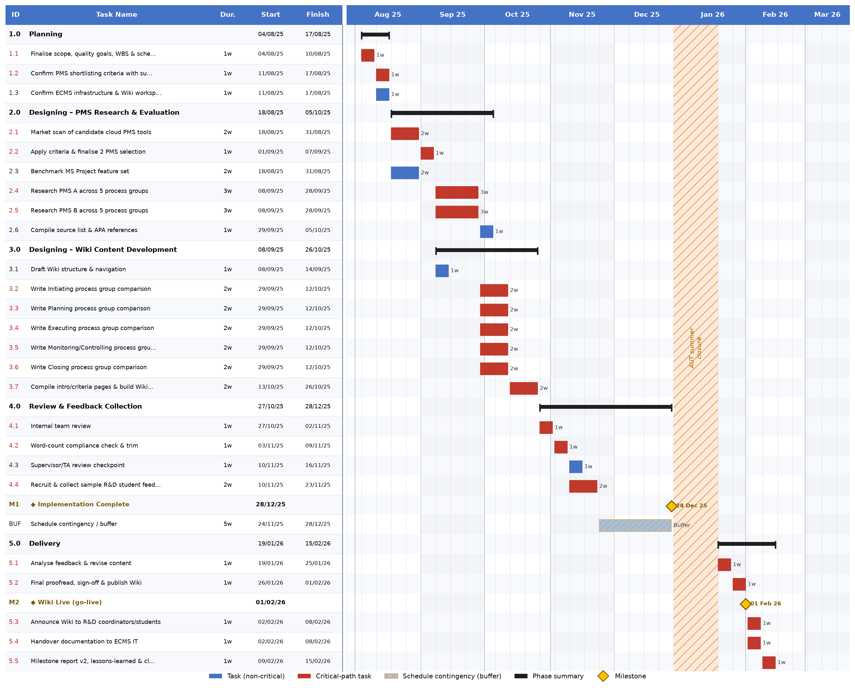

16b. Network Diagram
The diagram below is an Activity-on-Node (AON) network: each box is a work package, arrows show dependency, and boxes stacked in the same column can run concurrently because different people own them. Red-bordered boxes are the critical path (zero float, a delay to any one of them delays the whole project by the same amount); grey boxes carry float; gold boxes are milestones M1 and M2 are added phase-completion milestones (end of PMS Research & Evaluation, end of Wiki Content Drafting) used for progress tracking; M3 and M4 are the two brief-mandated milestones from the Business Case (Implementation Complete, Wiki Live).
Figure 2 – Network diagram (Activity-on-Node), critical path highlighted
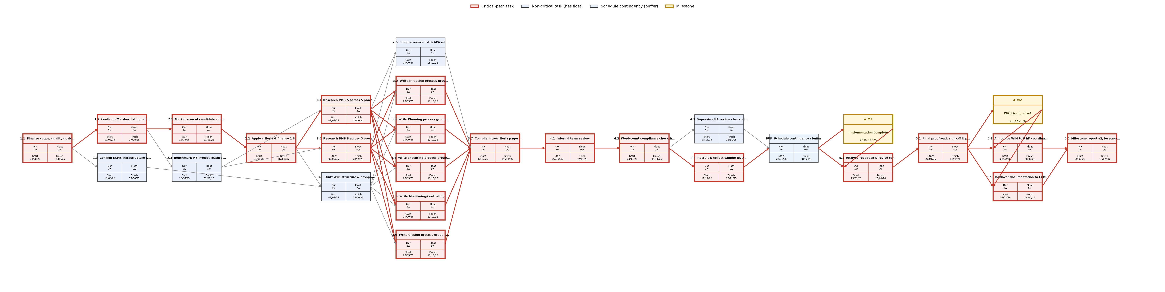

16c. Critical Path Analysis
Project duration: 25 working weeks of team effort (28 calendar weeks including the 5-week contingency buffer and the 3-week AUT closure), running from Monday 4 August 2025 to Sunday 15 February 2026, with the Wiki Live milestone landing on 1 February 2026 exactly the date the Business Case committed to.
Critical path: 1.1 → 1.2 → 2.1 → 2.2 → 2.4 → 2.5 → 3.2 → 3.3 → 3.4 → 3.5 → 3.6 → 3.7 → 4.1 → 4.2 → 4.4 → BUF → 5.1 → 5.2 → 5.3 → 5.4 → 5.5
20 of the 25 work packages sit on this path. A reminder that in a mostly sequential, small-team project, "critical" doesn’t mean rare. Only five work packages carry float:
WBS # | Work Package | Float | What the float means in practice
1.3 | Confirm infrastructure access | 5 wks | Can slip almost the whole planning phase without touching the schedule – low risk, can be delegated and checked on later
2.3 | Benchmark MS Project | 1 wk | One week of slack; useful if the same person is also on 2.1
2.6 | Compile references | 1 wk | Can finish up to a week after 2.4/2.5 without delaying 3.7
3.1 | Draft Wiki structure | 2 wks | Most slack of the "designing" packages – can be refined while research is still running
4.3 | Supervisor review | 1 wk | If the supervisor is slow to respond, one week is absorbed before it threatens the buffer

Effect of changes on project completion
Because float is zero along the whole critical chain, each of those 20 work packages has a single valid start/finish window the Start/Finish columns in §16a are simultaneously the early and late dates. There is no room to start any of them later than shown without pushing every downstream date back by the same amount.
The 5-week contingency buffer is the only true slack in the project, and it sits deliberately before Implementation Complete rather than scattered across individual tasks. A slip anywhere in Phases 1–4 (1.1 through 4.4) eats into that buffer first e.g. if PMS vendor pricing changes mid-research and 2.4/2.5 run a week over, Implementation Complete still lands on 30 Dec 2025, just with 4 weeks of buffer left instead of 5. If cumulative delays exceed 5 weeks, the buffer is fully consumed and Implementation Complete itself slips.
Once the team resumes after the AUT closure (19 Jan 2026), there is no float left anywhere. 5.1 and 5.2 sit on a hard, unbuffered 2-week countdown to go-live. A one-week delay to either a slow round of feedback revisions, a publishing hiccup pushes Wiki Live past 1 February 2026, the date the whole project exists to hit (R&D teams need the Wiki before Semester 1, 2026 begins). This is the single highest-risk point in the schedule and the one worth flagging explicitly to the supervisor.
5.3 and 5.4 run in parallel after go-live and don’t depend on each other, so neither creates a secondary bottleneck but 5.5 can’t start until both finish, so a delay to either one still delays project closure.

Sources
- Project facts (budget, dates, team, approach): Business Case & Project Charter, Assignment 1 Part 1.
- Brief requirements for items 15/16: Assignment 1_S2_2026.pdf, p.4.
- Method: PMBOK-aligned Work Breakdown Structure and Critical Path Method (forward/backward pass), as covered in the COMP507 Schedule Management lecture material.

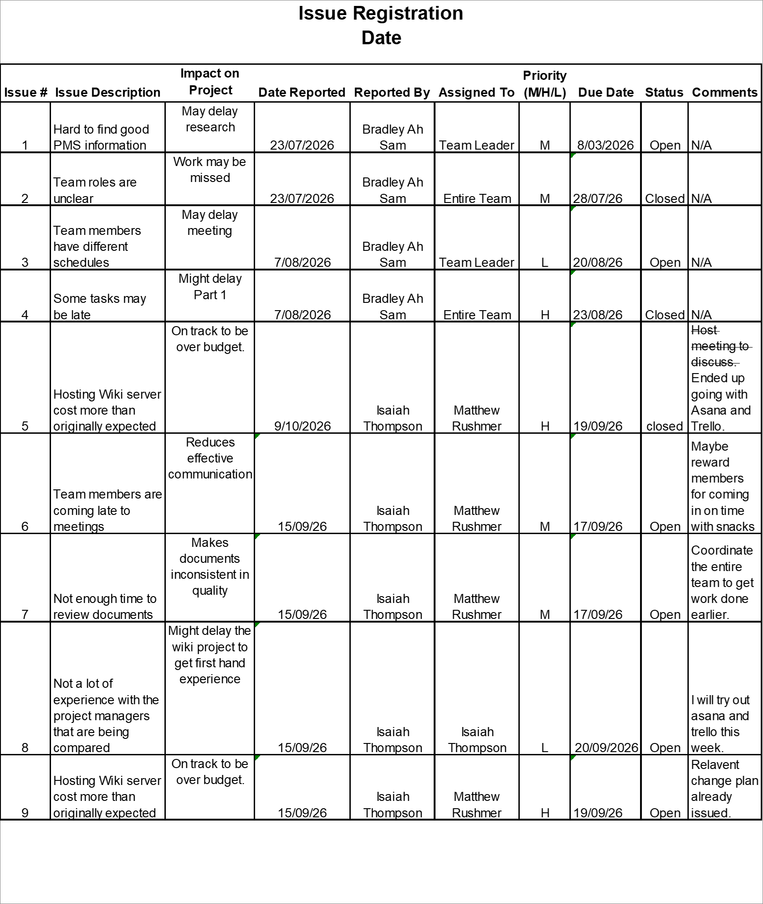

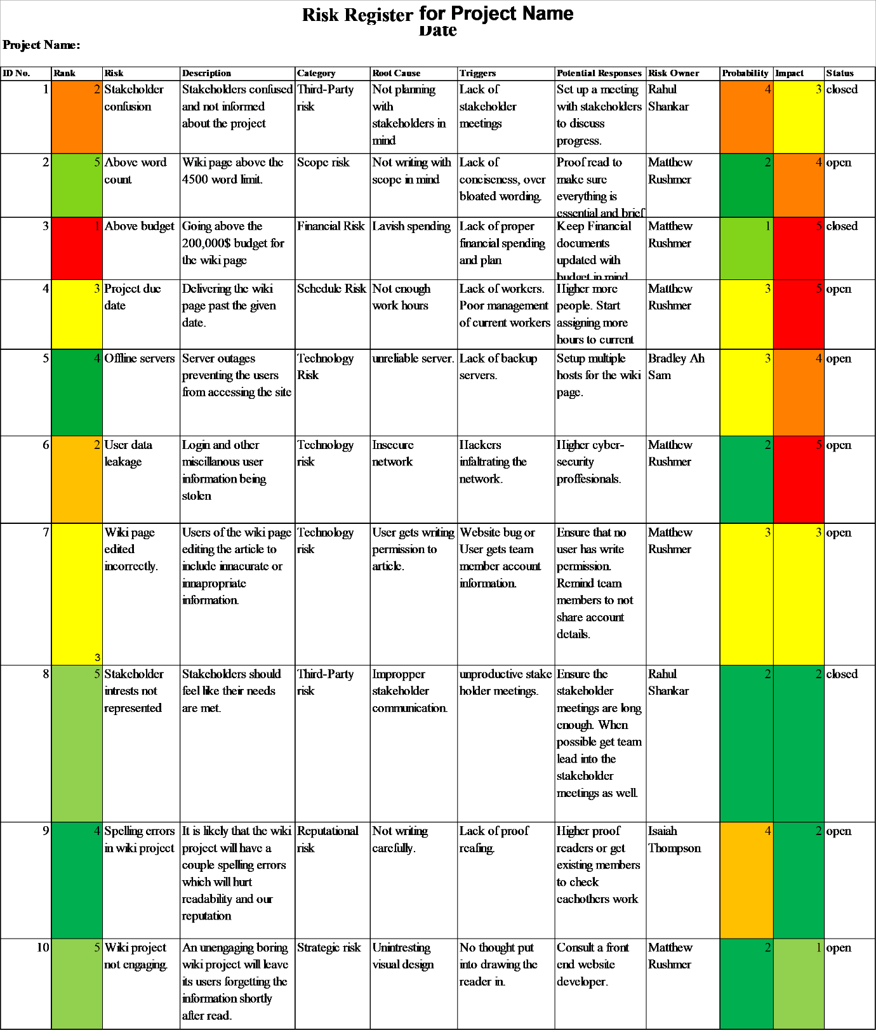

Project Milestone Report

Author: Bradley Ah Sam and Isaiah Thompson

Date: 17 . 09 . 26

Milestone | Date | Status | Responsible | Issues/Comments
Project team formed | 10/07/26 | Completed | Entire team | N/A
Roles and responsibilities assigned | 17/07/26 | Completed | Entire team | Matthew team leader.
Kick off meeting | 17/07/26 | Completed | Matthew Rushmer | N/A
Business case | 24/07/26 | Completed | Matthew Rushmer | N/A
Stakeholder register | 24/07/26 | Completed | Rahul Shankar | Confusion about the stakeholders. Solved.
Stakeholder management strategy completed | 24/07/26 | Completed | Matthew Rushmer | N/A
Project charter | 01/08/26 | Completed | Entire Team | N/A
Team contract signed | 01/08/26 | Completed | Entire Team | All members signed.
Risk register (Version 1) | 01/08/26 | Completed | Isaiah Thompson | N/A
Issue register (Version 1) | 15/08/26 | Completed | Bradley Ah Sam | N/A
Team meetings | 15/08/26 | Ongoing | Entire Team | Scheduling a time for all team members
Milestone report Version 1 | 15/08/26 | Completed | Bradley Ah Sam | N/A
Part 1 ready for submission | 15/08/26 | Upcoming | Entire Team | N/A
Meetings scheduled | 10/09/26 | Completed | Entire Team | Meeting for 10/09 and 17/09.
Rahul’s assigned documents completed | 14/09/26 | Completed | Rahul Shankar | Scope statement and lessoned learned documents.
Isaiah’s assigned documents completed | 15/09/26 | Completed | Isaiah Thompson | Change management plan, Risk register 2, Issue log 2, and Milestone report 2 documents.
Matthew’s assigned documents | 17/09/26 | Completed | Matthew Rushmer | Communication plan, WBS, Project Schedule documents
Part 2 ready for submission | 17/09/26 | Completed | Entire Team | N/A

